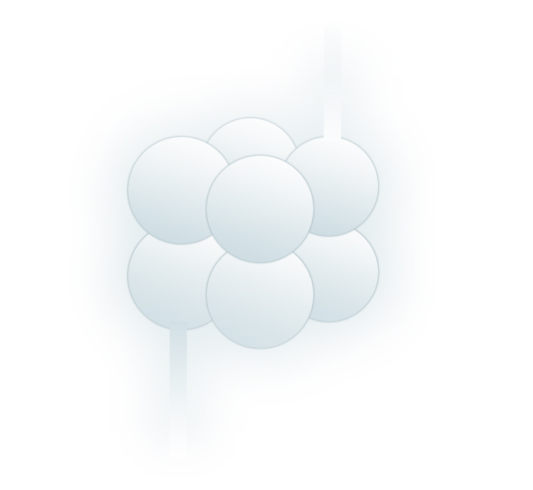 | Slovak Silicate Scientific-Technological Society  Koceľova 15, SK- 815 94 Bratislava, Slovak Republic  Tel.: +421-2-59410 429, Fax: +421-2-59410 444
APPLICATION FORM
I want to become a member of Slovak Silicate Scientific-Technological Society

First name and surname, title …………………………………………………………

Address, postal code …………………………………………………………

…………………………………………………………

…………………………………………………………

Workplace address, phone, e-mail …………………………………………………………

…………………………………………………………

…………………………………………………………

Date: ……………… Signature: ………………

